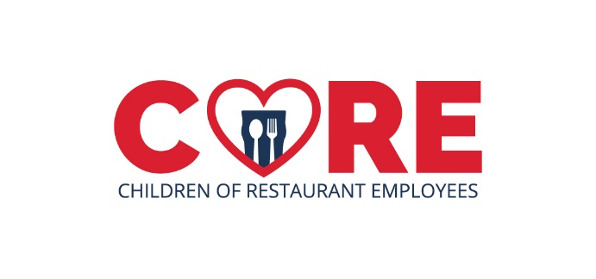
Employee Training Guide
Thank you for supporting CORE: Children of Restaurant Employees. We encourage you to share this information with your entire team. (The information below can be customized by you to include details about your fundraising promotion.
What is CORE?
CORE: Children of Restaurant Employee’s is a national non-profit that provides financial relief to food and beverage service employees with children when either the employee, spouse, or child faces a life-altering health crisis, medical diagnosis, death, or natural disaster. Founded to help our industry’s children, a CORE grant may cover rent/mortgage, utilities, out-of-pocket medical supplies, and/or basic necessities. To learn more about CORE’s grant criteria and required documentation, visit www.coregives.org . Companies and individuals have made generous donations to help employees that qualify for a grant when they face one of these crises.
CORE has helped employees with children in all 50 states, D.C., and Puerto Rico. Your company joins an industry-wide initiative to raise funds for employees in our industry that may face a qualifying circumstance. We will raise funds through (insert fundraising activity) and encourage our customers to donate to CORE at www.COREgives.org.
As an official CORE partner, we will also offer this resource for our employees with children that qualify for a grant.
How do we help?
Our company is honored to partner with CORE to raise critical funds needed for this industry focused cause. We will raise funds through (insert promotion/fundraising details and dates). Tell your guests about the fundraising promotion. Together we will help more families that face a qualifying circumstance.

To learn more about CORE, visit www.coregives.org and if you have questions, please contact CORE at Info@COREgives.org

